Instructions for Accepting Checks in VEND

This document is intended to assist each county office to understand the requirements for accepting checks through VEND. Please pay close attention to all components of the check.

Overview/key pieces of information:
- Checks should be reviewed at the moment it is received as well as during each deposit prepared.
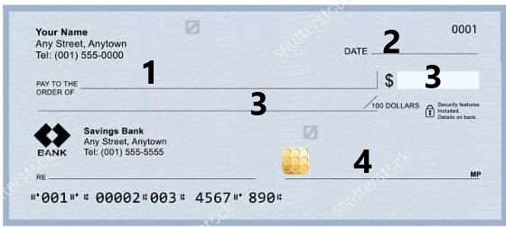

All fields of the check need to be completely filled in. Before accepting the check and completing the sale in VEND, review each area: (each number below corresponds to the example of the check above).

- Acceptable entry for “Pay to the order of” is: MSU, MSUE, Michigan State Extension, 4H, County 4H, or County Extension Office
  - Checks made out to an individual must be signed over and made Payable to MSU before this can be accepted.
- Ensure the date is not older than 5 months OR not dated for the future.
  - This is critical! Banks will not accept checks older than 6 months, so keep this in mind when taking a check. Consider time for deposit reporting period, signatures, etc.
  - Be sure there are no date restrictions – “void after 60 days”, etc. This is calculated from the date the check was issued not received.
- Ensure the legal and numeric amount match exactly.
  - If the check is written for two hundred dollars and 20/100 and the numeric amount is $220.00, this is not acceptable. Do not enter the sale in VEND.
- Ensure that the check is signed by issuer

Additional pieces of information to consider:
  - Ensure there is no more than ONE correction on the check.
    - Fixing the Pay to the order of is a correction
    - Fixing the written portion and the numeric portion are considered two errors.
    - Fixing the address is a correction
    - Fixing the date is a correction
  - Checks are not to be dated for in the future.
  - Add phone number of customer on the check by the name if it is not already provided
    - This helps in instances when the check has errors, needs to be returned and you have to follow up with the customer for a new payment.
  - Checks should be stamped for deposit only – (Including the cash sales check written by the county).

Each year, only during the month of January, banks are willing to be lenient on the year entered or being corrected because of the date change. When February starts, we are back to being stricter with the number of errors and should keep this in mind when receiving a check when the date has been corrected.

When entering the check information in the sale, please enter the check # in the notes section.

Contact msue.vend@msu.edu with any questions related to this topic.

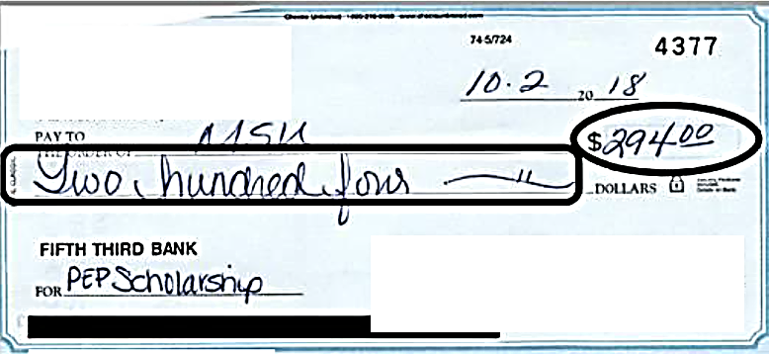
Below are some examples of checks which were returned due to errors

